A Trip to Västerbotten, Part 1 Aleda (Ostrom) and Jim Littlefield

In June 2019 (P.C.) we took trip to the Baltic Homelands aboard the liner Viking Seas. Our final port of call was Stockholm. After a few days there, which included National Day where we were held up by the king, we traveled farther north. Very far north. We wanted to visit Västerbotten county and the places where Aleda’s family had originated many years ago, specifically around the town of Sävar, only a few kilometers north of Umeå. More about that in the next essay (see Part 2).

We had previously made contact with a member of the Umeå Genealogical Society who had been very helpful in tracing Aleda’s maternal lineage. In fact, we were able to trace it back to 1630 for the male lines and even further for some female lines. Tommy Jacobsson, the genealogist, lives in Umeå. It is an 8 Hour drive from Stockholm on the E4 but only a one hour flight so we took a taxi out to Arlanda airport and flew north. Cab fare all the way to Umeå would have been too expensive although cab fare to the airport wasn’t cheap either as Arlanda is about half way to Uppsula. We were met at the Umeå airport by our host Tommy who helped to collect our luggage. As usual, our bags were the last ones off the plane. We stayed at the Clarion in downtown Umeå. Very nice and it has both a free breakfast and a free supper: all the fish and potatoes you can eat. You don’t find that everywhere!

For those of you whose forbearers emigrated from the south, the south of Sweden that is, where many Swedish immigrants came from, a bit about the North. Västerbotten, also known as West Bothnia, is a province in the northernmost Swedish län of Norland. It extends from the Gulf of Bothnia on the east to Norway on the west and Norbotten on the north. I won’t describe what’s to the south but it’s the same as to the north, which is mostly pine and fir and broadleaf trees such birch, rowan, alder and aspen. The vast forests of Västerbotten county have a land area about the size of West Virginia. Over half of the population of the county live in the towns of Umeå and Skellefteå. The population of the county is 268,000, hence quite sparse. We toured along the roads of Västerbotten looking for distant relatives and sometimes getting lost and searching for the stray cell-tower signal as there was really no one to stop and ask directions and the very few cows weren’t much help either.

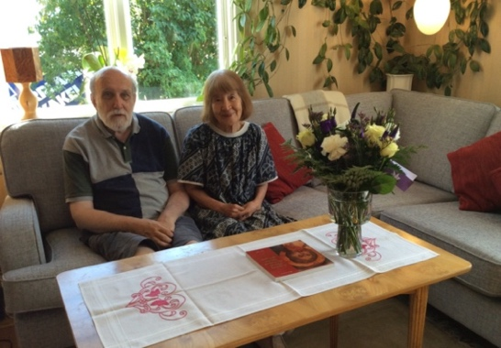
Over the next several days we were escorted about the county by Tommy and his wife Shuziko, taking us to the sites and sights around Umeå. Speaking of fish, Tommy and Shuziko invited to their lovely flat and they cooked a most amazing and delicious salmon dinner with fresh potatoes and veggies. He had met his wife in Japan and they are united by a lifelong love of music, particularly opera. Before the plague hit, they might hop in the car and drive the E4 south to Helsingborg and then to Milan via the A7 for a performance of Mozart or Verdi and then to Rome for a little Puccini.

Back to northern Sweden. A few examples of what we saw included the Museum of Västerbotten, an open air museum with a replica of a Sami camp sans Sami. It has a ski museum, a fishing exhibit and a small, traditional rural parish church which was moved from Holmon island. Even though near closing, we sought the key to transcendence, that is the front door, and once opened, we could see the inside.

One of the days we were in Umea was Studenten. This is the celebration of the students at the completion of the final year of secondary education. This is an annual outpouring of emotion and champagne in which the students ride around town in large dump-trucks or farm wagons and which have large white sheets draped along the sides of the wagons with pithy sayings painted thereon, such as:
PLUGGAR: MED VISS SAKERHET STUDYING: WITH SOME SURITY
FESTAR: UTFORLIGT & NYANSERAT PARTYING: EXTENSIVELY AND NUANCED
And
de ä latt att ha hybris You are allowed to have hubris
när man är bäst When you are (the) best.


These wagons are necessary because the students are all lustig, if you know what I mean. Almost all of the students wear their studentmõssa, what I would describe as a sailor’s hat with a white crown and a black visor and a band around the brim usually inscribed with their name on the front and the school’s name or pithy saying on the back. These hats are a relic from mid-nineteenth century German universities and first exhibited in Uppsala

We visited the art museum which had an exhibit of Car Johan de Greer consisting of large patterned fabric prints. De Geer is a somewhat controversial Swedish graphic-design artist with strong leftist sympathies though his work reminded me more of Escher than Soviet realism.

One must mention some of the natural wonders of northern Sweden. Out of the Scandinavian Mountains or Scandes (Scanderna) arise many rivers when flow and fall to the southeast into the Gulf of Bothnia. Although there is only a mild drop in elevation from the base of the mountains to the Gulf there is a fall line at the coastal plain where there are many rapids and waterfalls. These rivers were once used extensively for rafting logs from the forests (do you know the Swedish word: baggböleri ?) to the mills which used the waterfalls/rapids as a source of power for the saws. Nowadays their use - aside from electricity generation - is primarily recreational. We went to visit the Renforsen Rapids on the Vindelaven River and had a nice lunch there. We also visited the Umeå Energy Center, a.k.a. the Klabböle powerplant. Jim got to throw a giant knife switch but nothing happened as it was Sunday. There are over 1000 hydroelectric plants in Sweden which produce about 45% of Swedish electricity.

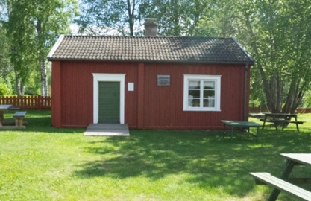
There was a living history museum where Herr Jacobsson introduced us to an interesting facet of Swedish history. Here there was a small cabin, a Soldattorp also known as an ekttorp. This is a dwelling or a croft (def. a small single family farm unit) built and used by a single soldier (and his family). The historical background of this relates to the necessity for the king to maintain a well-trained army but he couldn’t afford such in peacetime. A system was adopted in the 16th Century (Charles XI) - after Sweden’s secession from the Kalmar Union - called the Allotment System. The soldiers were called “croft soldiers’. The new system gave the conscripted soldiers a means of subsistence between campaigns (when they were paid by the Crown) by making a whole group of farmers (called “roots”) responsible for the keep of each soldier. This might be the equivalent of today’s “citizen soldiers” or our National Guard. In return, the “root farmers” got relief from military service for themselves. During peacetime, the soldier worked on the farms just as the other peasants. In return for their service, the farmers provided the land and the housing. The house base should be 8 x 4 meters and the height of the house seven logs high. In addition there were outbuildings such as a barn and a small plot of land to provide two loads of hay. I’m not certain who provided the cow.

In our next episode we will describe the countryside and scenes of the family’s history around the town of Sãvar and the Uma River. We met three of Aleda’s third cousins who live there, in fact one of whom still lives on the family farm that her grandparents left to move to southern Sweden before emigrating to the States. We ended out trip with fond farewells to Tommy Jacobsson and his wife Shizuko, our hosts and guides and tutors, as we flew back to Arlanda and then to the States.

