Part II Solving a Mystery by Jim and Aleda Littlefield

“We sold our homes and then we set out,
As birds fly away when summer is done,
The birds will return when springtime comes,
But we’ll not see our homes again.”
Swedish Immigrant Song, 1854, from the Bishop’s Hill Museum

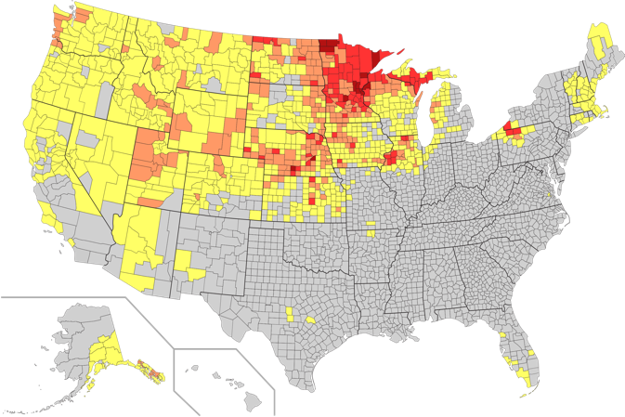
Aleda’s mother, Alice, was a full Swede, though she was born in the States. Her maiden name was Alice Elvira Ostrom. She was proud of her Swedish origins and said that the family had come from Virstad though she wasn’t sure where exactly in Sweden that was. As proof of her Swedish origins she would make Spritz cookies for us every Christmas, a tradition which Aleda carries on today. Alice was born in Erie, Pennsylvania, which is somewhat anomalous because by far the majority of Swedes emigrated to Minnesota and northern Wisconsin. Here is a map of the distribution of Swedish
Immigrants in the United States.

Alice died in 1991 and is buried in Lakeside Cemetery in Eire, PA. Aside from acknowledging that her parents came from Sweden at the end of the 19th Century and that she had several siblings, she never talked much about her upbringing and said even less of the family history, or at least that she wished to share. Sometime after her death, when it was too late to ask, Aleda decided to try to find out more about her origins. All of the older relatives had died as well so there was no one to ask. We were new to the genealogy game and so it was not a particularly successful undertaking. There were few Ostroms in the United States. One time when we were in Salt Lake City we tried the Family History Center but that didn’t reveal much of anything. One time in 2012 we were in Copenhagen for a meeting and decided to take the train up to Växjö in Smålan and visit the Swedish Emigrant Institute, located in the Utvandrarnas hus. (Comment: The family most likely passed through Växjö to get to Gothenburg from Virstad since Gothenburg was the main Swedish port for emigrants).

The Emigrant Institute has a small museum and a large library. There was a sign that said that one could hire a genealogist there to do research. Well, since we were already there, we said “säker, tak” and they provided us with a slightly inebriated Swedish genealogist. This was very helpful and he began to unlock the mystery of Aleda’s Swedish origins. We explained to him the lack of results we had so far in tracing the Ostroms. Well, many of you already know the answer. The problem was that we were tracing the family with an “O”, while the spelling in Swedish was with an “Å”. Once that was corrected, and using the extensive Swedish National Archives, we started the long retrospective trek of the family back to Västerbotten in Norland. Particularly valuable is the fact that most of the Swedish parish records have been digitized. Unfortunately, the Institute didn’t provide us with much “hard copy” and we took scribbled notes as fast as we could. But at least we knew where to start.

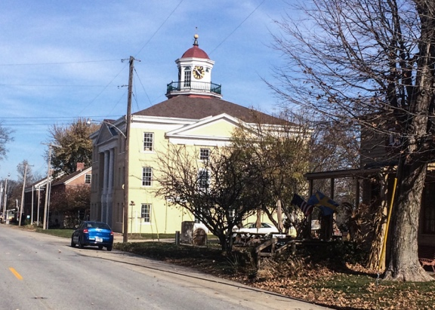
Over the years since then we have made further progress, for example in 2016 we took a trip to Rock Island, Illinois and visited with a genealogist there at the Swenson Swedish Immigration Center at Augustana College. They, at least, provided paper copies of the archival records. We also drove back home through Bishop’s Hill, Illinois a remnant of a Swedish immigrant colony founded by Swedish Pietists, called Janssonists, in 1846. No family history search was done there as Aleda’s family never left Pennsylvania (well, except for Aleda). Left: the Swedish museum in Bishop’s Hill, IL.

Our final piece of the puzzle (to be revealed in Part III) came to fruition in 2019. Having now established that the family had come from Vãsterbottenlän, particularly around the town of Sävar, Jim then established contact with one of the genealogical societies in Västerbotten, as listed in Wiki. Through the kind reference of that contact, we were able to connect with someone who has been – and continues to be – most helpful, Tommy Jacobssen. Besides being an expert genealogist – Jim likes to say that he has the entire population of Sweden back to the late Middle Ages (a bit of hyperbole) in his own computer database - he is an excellent researcher as well as a linguist, a polyglot, a historian, an excellent cook and a teacher. He is one of those rare people that you meet in one’s lifetime who is most fascinating and helpful.

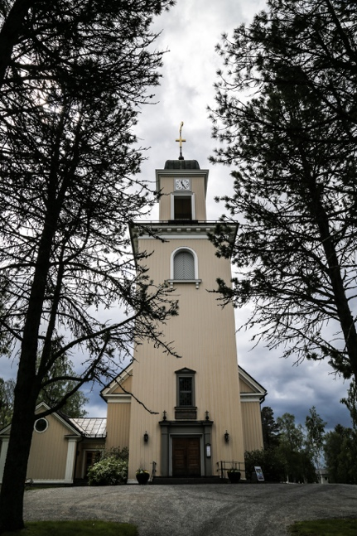
In 2019 we took a cruise on the Baltic, as mentioned in Part I, and the tour ended in Stockholm. I had previously contacted Tommy and he invited us up to Umeå. As described previously we toured around Umeå as well as driving around the countryside and visiting Sävar and the places where the family had lived. And not only that, he was able to track down three distant cousins who were living in the area. In fact, two were still living on the farms from which the family had left at the end of the 19th century to travel to America. He had made arrangements for us to meet them and to discover the homesteads and surrounding countryside of Aleda’s forbearers. Unfortunately, none of the cows they left behind were still out to pasture. We also visited the church in Sävar and the graveyard were some of the Ãstroms are buried.
Left: The church in Sävar.
More about this in the next episode.

